Discussion Guide
Planning for Equity – Stories from People Affected:
A Film and Discussion

California Planning Roundtable

CCAPA Conference Session, October 3, 2022

Prior to and during viewing of the film:
- Read the brief biographies of those interviewed (see reverse side).
- Jot down a few statements/sentiments shared during the film that resonate with you.

With a group, after the film is shown:
- How does the community where you were raised/work now compare with the experiences highlighted in the film? Things in common? Differences?

- What questions does/did the film raise for you?
  - What surprised you in the film?
  - What did you learn from the film?

- What have you observed are the major impacts that planning decisions have had on lower-income and minority neighborhoods?
  - Why have some impacts been negative?
  - How can planning have a more positive impact? What are the challenges? How can they be overcome?

- Why is it important to hear from and engage with people in diverse communities of color about planning issues?
  - Why can it be challenging?
  - What does successful engagement with people in diverse communities of color require? What are the constraints to doing this now?

- How does/will the film influence how you will go forward in your career as a planner, especially how you will engage communities of color?

- We would like you to share this film with other planners in your network―work colleagues, local planning groups. What would help you do that? What would hold you back?

Biographies of Film Interviewees

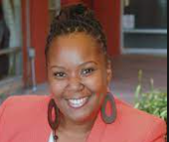
Ivory Chambeshi, MPA, MPL. Urban planner and social justice advocate, Los Angeles, CA
Born and raised in South Central Los Angeles, Ivory currently serves in Los Angeles Mayor Eric Garcetti’s Office as the Director of Neighborhood Initiatives for the Watts Rising Collaborative, a place-based, sustainable community development initiative co-led by the Housing Authority of the City of Los Angeles. She is implementing CA Transformative Climate Communities and U.S. HUD Choice Neighborhood Implementation grants, as well as the Jordan Downs public housing redevelopment.

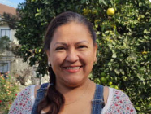
Rocina Lizarraga. Community organizer for a non-profit, San Diego, CA
As a Special Projects Coordinator for Olivewood Gardens and Learning Center, Rocina oversees transit, equity justice, and community outreach efforts in collaboration with the San Diego Assoication of Governments. She was born and raised in Mexico and is a 9th generation Kitchenista. Rocina serves as an elected member of the National City School District Governing Board.

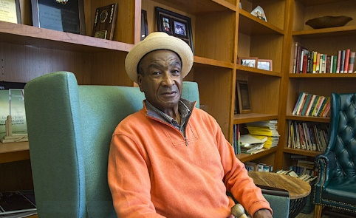
Oscar James. Community activist, San Francisco, CA
Oscar was born, raised, and still lives in Bayview Hunters Point and currently serves on the Board of Directors of the Dr. George Davis Senior Center in Bayview Hunters Point. His grandmother was the first Black person to purchase a home in Bayview Hunters Point in the late 1930s. Oscar began engaging in community issues as a teenager. He is now retired after working for several San Francisco City and County agencies.

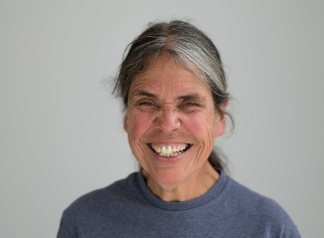
Maria Cortez. Long-time community advocate, Community Heights, San Diego, CA
Maria currently serves as a Community Outreach Assistant for Community Heights Development Corporation in San Diego, an organization that has worked to enhance the quality of life for residents of Community Heights by creating and sustaining quality affordable housing and livable neighborhoods and by fostering economic self-sufficiency.

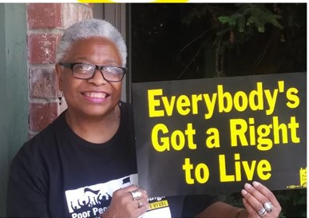
Faye Wilson Kennedy. Long-time community advocate, Sacramento, CA
Faye is a founding member of the Red Black and Green Environmental Justice Coalition (RBG EJC) and the Black Parallel School Board (BPSB). She also serves as a co-chair for the California Poor People’s Campaign (CA PPC) and co-led the Sacramento Poor People’s Campaign (Sac PCC). Faye lives, works, and organizes in Sacramento on the land of the Miwok/ Me-Wuk Peoples.

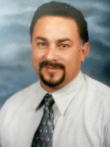
Javier Rodriguez. Community member, Roseville, CA
Javier grew up in Oakland, very close to the Fruitvale neighborhood. He is familiar with the many changes he has seen in this neighborhood over time―in racial demographics, economics, and how the neighborhood's home prices have gone up tremendously. He says that no one he knows can afford to buy a home there now.

